Antigone | Characterization (tragic flaw) ________________________  Evidence:  (law and order) Loyalty to _________  Evidence:  Fate versus free will  Evidence:
Creon  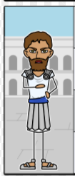 | Characterization (tragic flaw) _________________________  Evidence:  (law and order) Loyalty to _________  Evidence:  Fate versus free will  Evidence:
Haemon  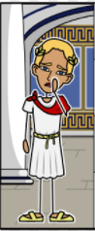 | Characterization (tragic flaw) ___________________________  Evidence:  (law and order) Loyalty to _________  Evidence:  Fate versus free will  Evidence:
Ismene  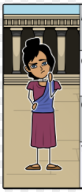 | Characterization (tragic flaw) ___________________________  Evidence:  (law and order) Loyalty to _________  Evidence:  Fate versus free will  Evidence:
Make sure you can identify these other significant characters:
Eteocles ________________________________ Polynices _____________________________________
Tiresias _______________________________ Eurydice _______________________________________

