Review: ‘Julius Caesar’ at The Public Theatre’s Shakespeare in the Park
By Richard Seff on June 16, 2017
We are in the streets of Rome. The lights onstage bump up and immediately we are in the midst of controversy. Flavius and Marullus are admonishing the crowd to break up and get on with their business. We are the Crowd, we are the Citizens of Rome. There are actors in the audience who are playing us, being asked why they are there, what is their work. They claim to be “making holiday to see Caesar, to rejoice in his triumph.”
Gregg Henry in Julius Caesar. Photo by Joan Marcus.
And for this, they are admonished; they are called “blocks, stones, worse than senseless things.” And we are off, in Oscar Eustis’ production of Shakespeare’s Julius Caesar where, as Artistic Director of The Public Theatre, he has created a blunt and vital revival that clearly speaks to our own times.
These times of ours are fraught with divisiveness, and Shakespeare was attracted to the same atmosphere in ancient Rome, as seen from his own perspective in the late 16th century. Mr. Eustis, sensing the relevance of the play to our own Trump-era America, has chosen to hammer home his point by casting the play satirically with Gregg Henry playing Caesar in a blue suit with a white shirt and long red tie. He has given him a wife, Calpurnia, who is dressed in the contemporary high fashion of Melania Trump, and Tina Benko plays her with a mid-European accent that is startlingly familiar to any of us who’ve been listening to Mrs. Trump on TV. To keep up with the times, the director has chosen the gifted Elizabeth Marvel to play Marc Anthony as a woman without changing a line of the text other than to refer to him as “her” throughout.
The conspirators, who will argue themselves into a coalition that will kill Caesar, are a multi-ethnic band of excellent actors. They are headed by John Douglas Thompson as Cassius (the lean and hungry one) and include Corey Stoll plays Brutus, Teagle F. Bougere as Casca, Edward James Hyland as Cicero, and others. All of these fine actors are capable of rendering the text clearly in American accents, and they’ve been directed to perform truthfully in a contemporary manner.
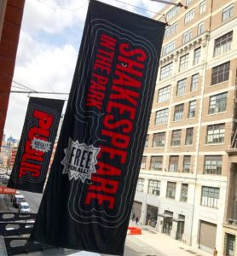
The use of the audience as very much part of the action is occasionally unnerving, but effective. At least two dozen young actors have been discreetly placed among us so that when needed, they are there to robustly respond to the reports of Caesar’s death (no spoiler here, I assume we all knew that he gets to say “E Tu Brute?” to his friend Brutus, whose knife finally does him in). Our “fellow Roman citizens” must be won over by Mark Anthony, whose “Friends, Romans, Countrymen” soliloquy must turn us around to realizing what crimes have been committed in the name of the Empire. It was all very engrossing, and the audience listened attentively, and stuck with it to the very end, when they showed their appreciation.
For me, I found the shenanigans that went on late in the play, and the intrafamilial fights and feuds that transpired after the murder and the trials, to be less interesting than the many scenes that preceded them. The arguments that Anthony used to rouse the Crowd were brilliantly conceived and executed, and Ms. Marvel made us forget the arbitrary use of a woman adopting a male role.
In the vast outdoor space provided by the Delacorte Theatre in the middle of Central Park, birds flew about and the occasional helicopter roamed the sky. The atmosphere was created not only by the artistry of Jessica Paz’s excellent sound design, by David Rockwell’s flexibly rotating scene flats, and by the very topical costumes of Paul Tazewell, but also by unbilled Mother Nature, who joined the stagehands in shipping in clouds and breezes that kept everything in the moment. Lighting and sound made a great contribution, as well.
Again, I think some of the topical references were unsubtle; I think I’d have preferred to let the play speak for itself in terms of its relevance to the Trump Administration. But it’s the sort of experiment for which The Public is famous, and if it stimulates its audiences – as it seems to be doing even to the point of controversy – well, that sounds like a big achievement for an organization called The Public Theatre.
Running Time: Two hours, with no intermission.
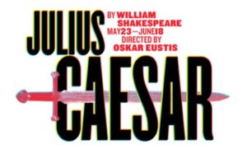
Julius Caesar plays through June 18, 2017 at The Public Theatre performing at the Delacorte Theatre in Central Park, New York, NY. Tickets are distributed in front of the Delacorte Theater on a first-come, first-served basis at 12:00 pm every day there is a public performance (get there very early) and via digital lottery online.

